Pen Blends Rubric 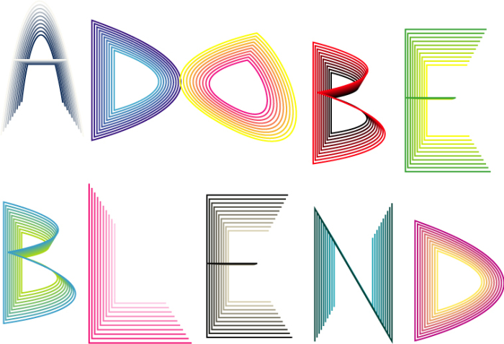

 | Always  10 Points | Almost Always  8 Points | Sometimes  6 Points | Rarely  4 Points | Never  2 Point
Sneaker design shows detail using multiple layers and/or blend designs - items overlap where necessary and do not have pieces missing (gaps)
Blend tool was used accurately on all lines and/or shapes (color blends or line blends) allowing a 2-D image become 3-D
Blend project fills the composition in an interesting & creative way and includes a background color or gradient
A variety of blend patterns were used to show details - not everything is solid color or has same amount of lines
Composition is unique, creative, and shows effort. Composition was completed on time

Total: ________/50

